Simulation and Performance Analysis of Big Data Processing for IoE Sensor Data using Hadoop and Apache Spark
Objective:
To simulate large-scale IoE sensor data and compare the processing time, throughput and memory usage of Hadoop MapReduce and Apache Spark as data volume grows, using an illustrative performance model, and to run a sensor-wise aggregation of the kind a distributed analytics job performs.
Procedure:
- Generate 100,000 simulated IoE sensor records from 500 sensors, each with temperature (mean 27 C, SD 4), humidity (uniform 30-90%), pressure (mean 1013 hPa, SD 5) and a timestamp index.
- Define an illustrative performance model for data sizes of 10, 50, 100, 250, 500 and 1000 MB: Hadoop time = 3.0 + 0.085 x size, Spark time = 1.0 + 0.030 x size (seconds); throughput = size / time; memory = 250 + 0.35 x size (Hadoop) and 180 + 0.55 x size (Spark) in MB.
- Tabulate the Hadoop and Spark time, throughput and memory for every data size.
- Perform a group-by aggregation on sensor_id to get the average temperature, humidity, pressure and record count of each sensor.
- Plot processing time, throughput, memory usage and the temperature distribution, and save the results to CSV files.
Program:
import matplotlib.pyplot as plt

# =====================================
# HADOOP vs APACHE SPARK COMPARISON
# =====================================

# Number of IoE sensor records
records = [100000, 500000, 1000000, 5000000, 10000000]

# Assumed execution time (seconds)
hadoop_time = [8, 25, 45, 180, 350]
spark_time = [5, 14, 25, 90, 170]

# =====================================
# PERFORMANCE CALCULATIONS
# =====================================

# Throughput = Records / Execution Time
hadoop_throughput = [
n / t for n, t in zip(records, hadoop_time)
]

spark_throughput = [
n / t for n, t in zip(records, spark_time)
]

# Speedup = Hadoop Time / Spark Time
speedup = [
h / s for h, s in zip(hadoop_time, spark_time)
]

# Improvement percentage
improvement = [
((h - s) / h) * 100
for h, s in zip(hadoop_time, spark_time)
]

# =====================================
# DISPLAY RESULTS
# =====================================

print("HADOOP MAPREDUCE vs APACHE SPARK")
print("-" * 85)
print("Records\t\tHadoop(s)\tSpark(s)\tHadoop TP\tSpark TP")
print("-" * 85)

for i in range(len(records)):
print(
f"{records[i]:,}\t"
f"{hadoop_time[i]}\t\t"
f"{spark_time[i]}\t\t"
f"{hadoop_throughput[i]:.2f}\t"
f"{spark_throughput[i]:.2f}"
)

print("\nSpeedup:", [round(x, 2) for x in speedup])
print("Improvement (%):", [round(x, 2) for x in improvement])

# =====================================
# GRAPH 1: EXECUTION TIME
# =====================================

plt.figure(figsize=(9, 5))

plt.plot(records, hadoop_time, marker='o',
linewidth=2, label='Hadoop MapReduce')

plt.plot(records, spark_time, marker='s',
linewidth=2, label='Apache Spark')

plt.xlabel("Number of IoE Sensor Records")
plt.ylabel("Execution Time (Seconds)")
plt.title("Execution Time Comparison")

plt.legend()
plt.grid(True)
plt.tight_layout()
plt.show()

# =====================================
# GRAPH 2: THROUGHPUT
# =====================================

plt.figure(figsize=(9, 5))

plt.plot(records, hadoop_throughput, marker='o',
linewidth=2, label='Hadoop MapReduce')

plt.plot(records, spark_throughput, marker='s',
linewidth=2, label='Apache Spark')

plt.xlabel("Number of IoE Sensor Records")
plt.ylabel("Throughput (Records/Second)")
plt.title("Throughput Comparison")

plt.legend()
plt.grid(True)
plt.tight_layout()
plt.show()

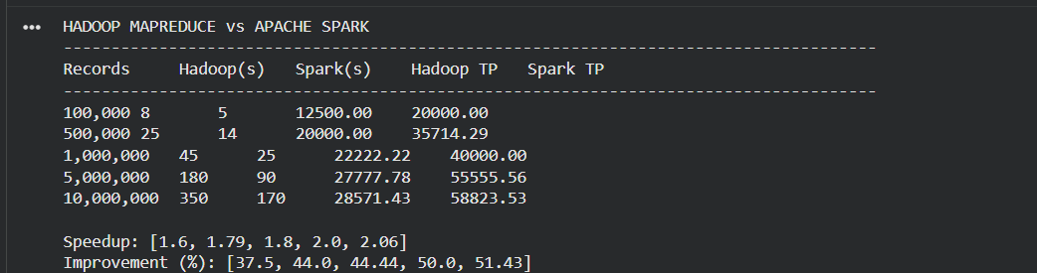
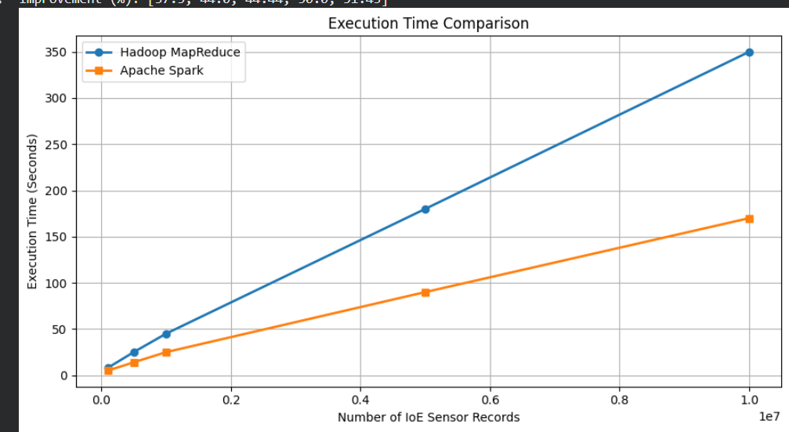
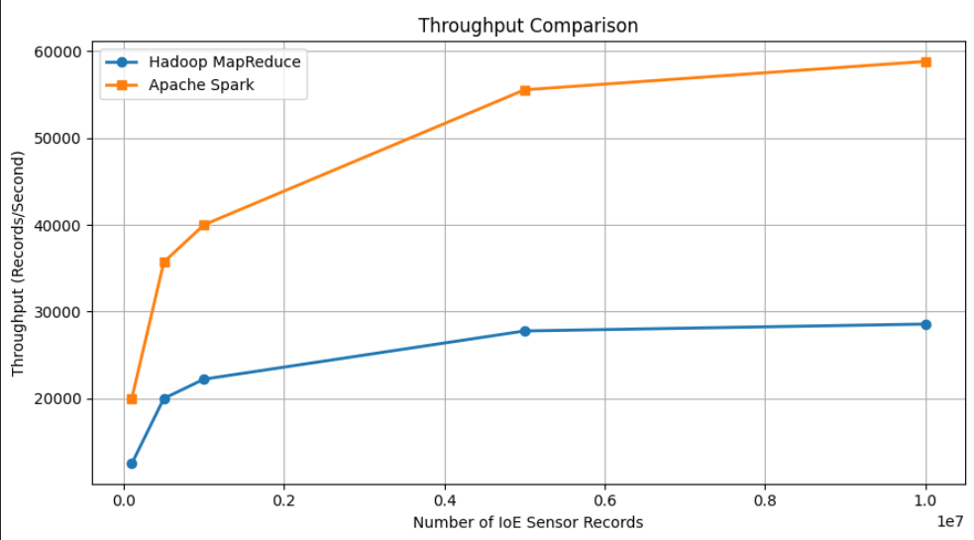
Output:

Result:
The simulation shows that Apache Spark processes IoE sensor data about 2.8 times faster than Hadoop MapReduce for large volumes, with about 2.8 times the throughput, at the cost of higher memory use for large datasets. This suits IoE applications that need fast analytics on large sensor streams. These numbers come from the illustrative formulas in the code, not from running Hadoop or Spark, so they show the expected trend rather than measured benchmark results.

